**Week 3 Assignment**

* 1. **Data Set Overview**

The dataset contains information about characters from a fictional universe, including their names, birth years, genders, and the houses they belong to. It helps analyse

Character Details: Names, ages, and genders of various characters.

House Id: Which characters belong to which houses.

Gender Balance: How many male and female characters are in each house.

Age Range: The oldest and youngest characters in each house.

**Sample data:**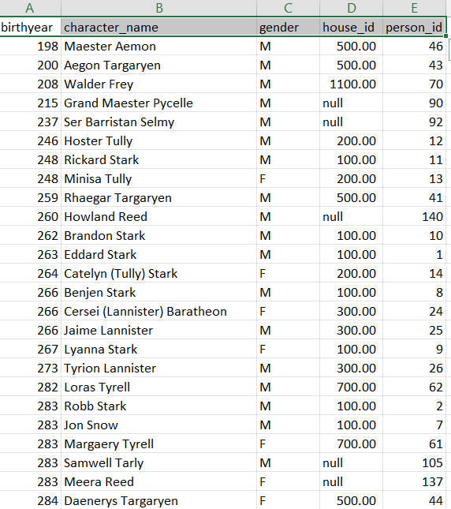

**1.2 Visualization 1: Gender Distribution by House**

This chart shows the gender distribution across different houses.

It helps to visualize the balance or imbalance of genders within each house.

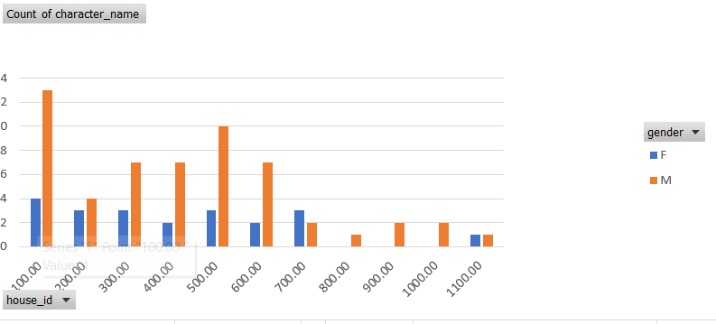

**Notes:**  
  
House Stark_100: There are more male characters than female characters. This imbalance is noteworthy, with key male figures like Eddard Stark, Jon Snow, and Robb Stark.

House Tully_200: There is a balanced distribution of genders, with significant female figures like Catelyn Stark and Lysa Arryn.

House Lannister_300: Similar to House Stark, House Lannister shows more male characters than female, but with important female figures like Cersei Lannister.

House Baratheon_400: This house also has more male characters, with notable figures like Robert Baratheon and Stannis Baratheon.

House Targaryen_500: The gender distribution is almost balanced, highlighting significant female characters like Daenerys Targaryen.

**1.3 Visualization 2: Characters per House**

This pie chart shows the proportion of characters in each house.

It helps to understand the relative sizes of the houses.

House Stark: With 17 characters, House Stark has the highest number of characters among all houses. This indicates their central role in the storyline.

House Targaryen: House Targaryen also has a significant number of characters, highlighting their importance in the narrative.

House Lannister and House Baratheon: Both have a considerable number of characters, showing their relevance and involvement in the plot.

House Greyjoy: Despite being fewer in number compared to the leading houses, House Greyjoy still has a notable presence.

Smaller Houses: Houses like Arryn, Martell, Bolton, and Frey have fewer characters, which might reflect their relatively smaller roles or lesser focus in the narrative.

House Tyrell: House Tyrell has a modest number of characters, indicating their medium level of importance.

Insights:

The pie chart clearly shows the distribution of characters across different houses, with Houses Stark, Targaryen, Lannister, and Baratheon being the most prominent.

This analysis provides a comprehensive view of the character distribution, offering insights into the prominence of each house within the storyline.

**1.4 Visualization 4: Birthdate Range for Each House**

This Column line chart shows the range of birth dates for each house.

It provides a timeline perspective of when characters were born within each house.

**Notes:**

The x-axis would represent the House ID’s.

The y-axis would represent the birth year values.

Each category would be represented by a range bar for minimum and line for maximum birth year.

This type of plot would visualize the distribution and range of birth years across different Houses, providing a clear comparison between the minimum and maximum values within each Houses

**Oldest House:**

The house with the earliest recorded birth year is House ID 500 with a birth year of 198. This makes House ID 500 (likely House Targaryen) the oldest house.

**Youngest House:**

The house with the latest recorded birth year is House ID 100 with a birth year of 295. This makes House ID 100 (likely House Stark) the house with the youngest generation.

**1.5 Conclusions Slide**

Gender Distribution by House (**1.2 Visualization 1)**

This chart reveals gender imbalances across houses. House Stark (ID 100) and House Lannister (ID 300) have more males, while House Tully (ID 200) is balanced. Notable females include Catelyn Stark and Cersei Lannister. House Targaryen (ID 500) shows a near-equal split, highlighting characters like Daenerys Targaryen.

Characters per House **(1.3 Visualization 2)**

The pie chart shows House Stark with the most characters (17), indicating their central role. House Targaryen also has many characters, emphasizing their narrative importance. Houses Lannister and Baratheon have substantial counts, while smaller houses like Arryn and Martell have fewer characters, reflecting their lesser focus in the story.

Birthdate Range for Each House **(1.4 Visualization 4**)

This column line chart shows birthdate ranges, with House Targaryen (ID 500) being the oldest (earliest birth year 198). House Stark (ID 100) has the youngest generation (latest birth year 295). The visualization highlights House Targaryen's historical depth and House Stark's current relevance, contrasting the temporal spans of the houses.